Outline

Short and long-term treatment with modafinil differentially affects adult hippocampal neurogenesis

M.D. Brandt, E. Ellwardt, and A. Storch

Federico Reyes

1. Introduction
2. The hippocampus is one of the two places where cell neurogenesis takes place in the brain. Hippocampal neurogenesis specifically takes place in the dentate gyrus
3. Hippocampal Neurogenesis helps us learn new information and store it by making new pathways
4. Neurogenesis might help us understand diseases that happen when the hippocampus stops working like dementia, depression, and schizophrenia
5. Modafinil(Mdf) is a drug that is given to people with narcolepsy and keeps you awake
6. Narcolepsy is caused by a lack of the orexin neurotransmitter and Mdf activates the orexinergic system (Ishizuka et al., 2012).
7. Mdf also helps with Parkinson’s disease since its caused by a lack of dopaminergic neurons and Mdf has been found to protect these neurons (van Vliet et al., 2008)
8. Mdf has been reported to improve memory and learning in humans and rodents (Beracochea et al., 2001, Beracochea et al., 2002, Muller et al., 2004, Muller et al., 2013 and Shuman et al., 2009).
9. Mdf studied because data is inconsistent. There is evidence Mdf improves memory and synaptic plasticity, (Tsanov et al., 2010) but it was also found that Mdf decreases neurogenesis when given every 4 hours (Kochman et al., 2009) possible due to sleep deprivation that Mdf causes (Mirescu et al., 2006 and Guzman-Marin et al., 2007).

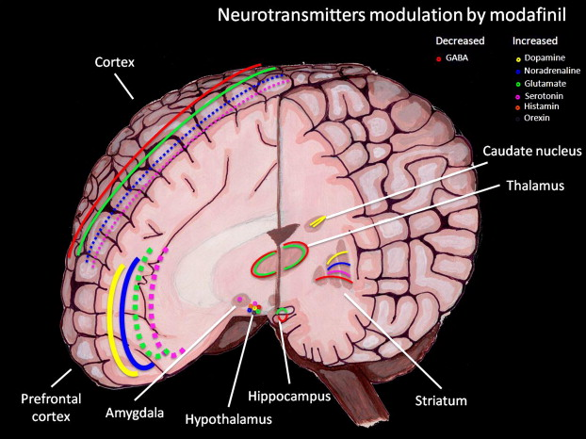

1. Purpose
2. To look at the effects of different treatment lengths and different treatment patterns of Modafinil in mice on cell proliferation, cell survival, and net neurogenesis.
3. If the scientists gave different length treatments and different treatment patterns of Modafinil to mice, then cell proliferation, cell survival and net neurogenesis will change because Modafinil has been found to promote the process of neurogenesis.
4. Methodology
5. All mice were eight week old female mice kept in laboratory cages and given free access to food
6. For each experiment, 5 mice were placed in the Mdf group and given 64-mg/kg of Mdf once daily. Another 5 mice were used as a control
7. This specific dosage was used because it was found to affect cognition without inducing sleep-deprivation (Beracochea et al., 2001 and Tsanov et al., 2010)
8. In the first experiment, mice were injected with Mdf once daily in the evening for four consecutive days. This is referred to as the cyclic group because the time of the injection doesn’t interrupt the mice’s sleeping patterns. The mice were injected with 5-bromo-deoxyuridine (BrdU) to label proliferating cells on the three days between the Mdf injections. The mice were then euthanized the day after the last Mdf injection
9. The second experiment was the same as the first but the Mdf injection occurred in the morning. This was called the anti-cyclic group because it was given right before the mice’s resting period and might affect their circadian rhythm in a way that decreases neurogenesis
10. The third experiment was also similar to the first but the mice were euthanized 21 days after the last BrdU injection to measure net neurogenesis
11. In the fourth experiment, the mice were injected with BrdU for 3 days but injected with Mdf on days 9 and 12 to test the effect of Mdf on the survival of the new cells. Mice were euthanized on day 13
12. The fifth experiment tested the effect of a long treatment of Mdf. Mice were injected with Mdf once daily for 14 days but they were injected with iodeoxyuridine (IdU) on days 2-4 and chlorodeoxyuridine (CldU) on days 12-14. Mice were euthanized on day 15
13. Only cells in the subgranular or granular zone of the dentate gyrus were used

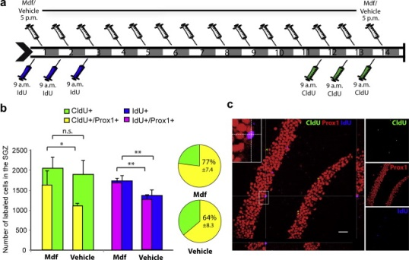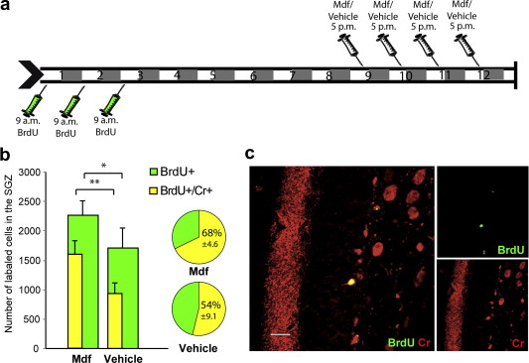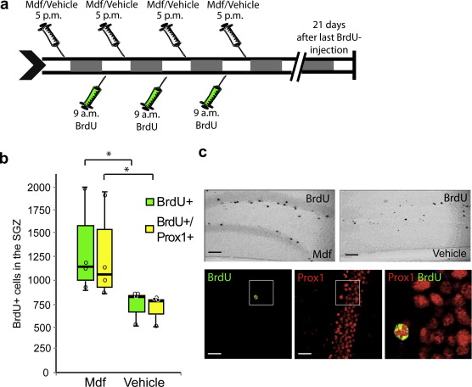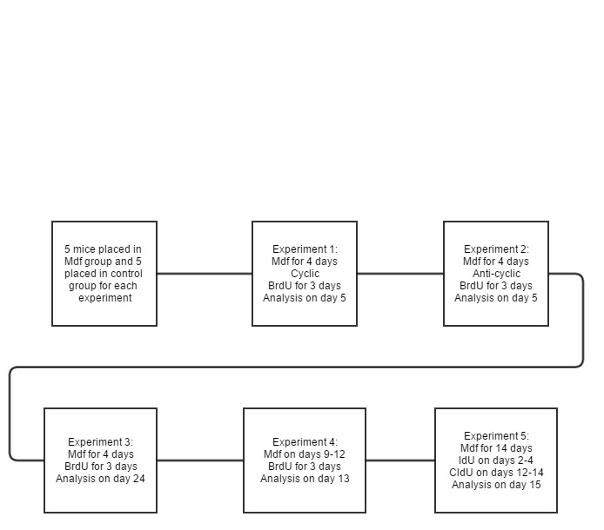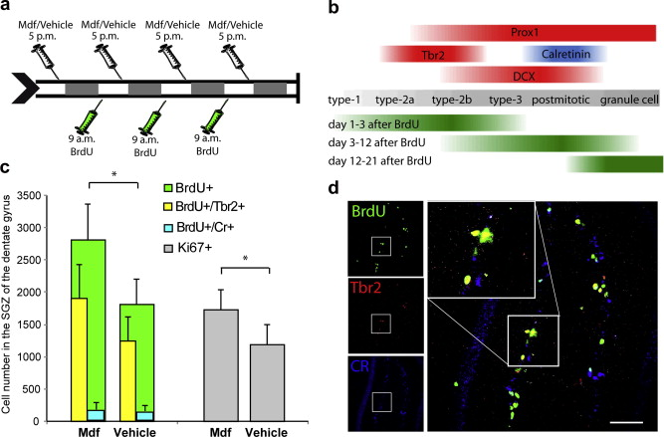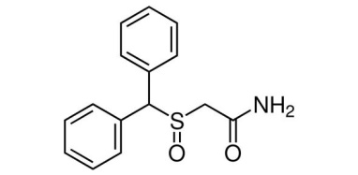

1. Results
2. Experiments 1 and 2 tested the effects of short-term treatment on proliferation. The cyclic group had 55% more BrdU labeled cells than the control and the anti-cyclic group had 24% more BrdU-labeled cells than the control. There were also more Ki67+ cells, those still in the cell cycle, so Mdf helps proliferating cells. Same level of early neuronal precursor cells measured with Trb2 and newborn post-mitotic cells measured with calretinin (Cr).
3. Experiment 3 tested net neurogenesis so the analysis was done three weeks after the last BrdU injection since it takes 2-3 weeks to determine if the new cells survived. There was a big increase in net neurogenesis in the Mdf group. 93% of the cells had the Prox1 marker, meaning they came from the granule cells.
4. The survival of the cells is affected by proliferation, apoptosis right after birth and another apoptotic period a week after birth. The fourth experiment tested to see if Mdf would help with the survival of the cells during the second apoptotic period by having injection after a week. The mice treated with Mdf had higher BrdU labeled cells and they also had a higher proportion of Cr cells vs Trb2. The Mdf had 68% Cr/Trb2 cells and the control had 54% Cr/Trb2 cells. The Mdf-treated mice also had a greater increase of Cr labeled cells.
5. The final experiment was used to test the effects of long-term Mdf treatment on neurogenesis. IdU was used in the beginning of the trial to measure new cells made at the beginning and CldU was used to measure the amount of cells that kept proliferating. There were 29% more IdU labeled cells in the Mdf treated mice than the control. There was no change in CldU labeled cells from the control, however.
6. Discussion
7. Short term treatment with Mdf increased proliferation of the cells since there were more Ki67+ cells. Short term treatment increased the number of Brdu+ cells and thus neurogenesis.
8. Mdf treatment with the cycle also had better results than Mdf treatment against the mice biorhythm cycle. Hippocampal neurogenesis has also been found to decrease in a mice simulation of “jet lag” (Gibson et al., 2010, Kott et al., 2012)
9. There was no difference in proliferating cells at the end of the long treatment, so Mdf has no additive effects on proliferation. It affects it at the beginning of treatment and doesn’t affect it after a certain amount of time
10. Mdf boosts survival of cells since there was a 73% increase of Cr+ cells after Mdf treatment. More cells in a post-mitotic stage indicate that Mdf promotes survival of the cells.
11. Mdf treatment can decrease neurogenesis due to loss of sleep caused by an Mdf dosage that caused sleep deprivation (Kochman et al., 2009) but Mdf can increase neurogenesis in a dose that doesn’t cause sleep deprivation
12. It’s unknown how exactly Mdf boosts neurogenesis and the mechanics of it is definitely something that should be further studied. Mdf increases production of dopamine, noradrenaline, histamine, and hypocretin (Minzenberg and Carter, 2008) so the effects of these should be further studied.
13. Another possible explanation for the increase in neurogenesis could be that Mdf causes increased alertness and brain activity and increased activity has been found to increase neurogenesis and help promote the survival of existing neurons. (Piatti et al., 2011)
14. Neurogenesis is also boosted by an enriched environment and increased complexity and novelty in their surroundings. It should be further studied if these behavioral changes could have been cause by the Mdf and whether that is what caused increased neurogenesis.
15. An extraneous variable in this experiment could be that the decreased amount of proliferation after long-term treatment in the mice could be due to injection-induced stress. Stress has been found to decrease neurogenesis (Cameron and Gould, 1994, Malberg and Duman, 2003).
16. Conclusion
17. The purpose of this study was to see if Modafinil given in different forms would increase or decrease neurogenesis in the hippocampus. It was found that short term treatment of Modafinil boosted proliferation of stem cells, survival of new cells, and thus a general increase in net neurogenesis. It was found that an extended treatment did not further improve neurogenesis, but there are some factors that must be taken into account and it must be further studied to make a firm conclusion.
18. Hippocampal neurogenesis is a topic of study that is increasing in popularity because of the possibilities of unlocking its secrets. Understanding neurogenesis can help us learn faster, retain better memories, help people with dementia, depression, and schizophrenia. Modafinil is a drug that has wake-promoting effects, neurogenesis-promoting effects, and can even help people with Parkinson’s disease. It is definitely a topic of further study due to its diverse uses.
19. Review of Literature
20. **Beracochea et al.,** 2001 D. Beracochea, B. Cagnard, A. Celerier, J. le Merrer, M. Peres, C. Pierard First evidence of a delay-dependent working memory-enhancing effect of modafinil in mice Neuroreport, 12 (2001), pp. 375–378
21. **Cameron and Gould, 1994** H.A. Cameron, E. Gould Adult neurogenesis is regulated by adrenal steroids in the dentate gyrus Neuroscience, 61 (1994), pp. 203–209
22. **Guzman-Marin et al., 2007** R. Guzman-Marin, T. Bashir, N. Suntsova, R. Szymusiak, D. McGinty Hippocampal neurogenesis is reduced by sleep fragmentation in the adult rat Neuroscience, 148 (2007), pp. 325–333
23. **Ishizuka et al., 2012** T. Ishizuka, T. Murotani, A. Yamatodani Action of modafinil through histaminergic and orexinergic neurons Vitam Horm, 89 (2012), pp. 259–278
24. Muller et al., 2004 U. Muller, N. Steffenhagen, R. Regenthal, P. Bublak Effects of modafinil on working memory processes in humans Psychopharmacology (Berl), 177 (2004), pp. 161–169
25. Muller et al., 2013 U. Muller, J.B. Rowe, T. Rittman, C. Lewis, T.W. Robbins, B.J. Sahakian Effects of modafinil on non-verbal cognition, task enjoyment and creative thinking in healthy volunteers Neuropharmacology, 64 (2013), pp. 490–495
26. Mirescu et al., 2006 C. Mirescu, J.D. Peters, L. Noiman, E. Gould

Sleep deprivation inhibits adult neurogenesis in the hippocampus by elevating glucocorticoids Proc Natl Acad Sci USA, 103 (2006), pp. 19170–19175

1. Minzenberg and Carter, 2008 M.J. Minzenberg, C.S. Carter Modafinil: a review of neurochemical actions and effects on cognition Neuropsychopharmacology, 33 (2008), pp. 1477–1502
2. Malberg and Duman, 2003 J.E. Malberg, R.S. Duman Cell proliferation in adult hippocampus is decreased by inescapable stress: reversal by fluoxetine treatment Neuropsychopharmacology, 28 (2003), pp. 1562–1571
3. Piatti et al., 2011 V.C. Piatti, M.G. Davies-Sala, M.S. Esposito, L.A. Mongiat, M.F. Trinchero, A.F. Schinder The timing for neuronal maturation in the adult hippocampus is modulated by local network activity J Neurosci, 31 (2011), pp. 7715–7728
4. Shuman et al., 2009 T. Shuman, S.C. Wood, S.G. Anagnostaras Modafinil and memory: effects of modafinil on Morris water maze learning and Pavlovian fear conditioning Behav Neurosci, 123 (2009), pp. 257–266
5. Tsanov et al., 2010 M. Tsanov, D.G. Lyons, S. Barlow, R.E. Gonzalez Reyes, S.M. O’Mara The psychostimulant modafinil facilitates water maze performance and augments synaptic potentiation in dentate gyrus Neuropharmacology, 59 (2010), pp. 9–1
6. van Vliet et al., 2008 S.A. van Vliet, E.L. Blezer, M.J. Jongsma, R.A. Vanwersch, B. Olivier, I.H. Philippens Exploring the neuroprotective effects of modafinil in a marmoset Parkinson model with immunohistochemistry, magnetic resonance imaging and spectroscopy Brain Res, 1189 (2008), pp. 219–228
7. Kochman et al., 2009 L.J. Kochman, C.A. Fornal, B.L. Jacobs Suppression of hippocampal cell proliferation by short-term stimulant drug administration in adult rats Eur J Neurosci, 29 (2009), pp. 2157–2165
8. Brandt et al., M.D. Brandt, E. Ellwardt, A. Storcha Short- and long-term treatment with modafinil differentially affects adult hippocampal neurogenesis Neuroscience, 278 (2014), pp. 267-275